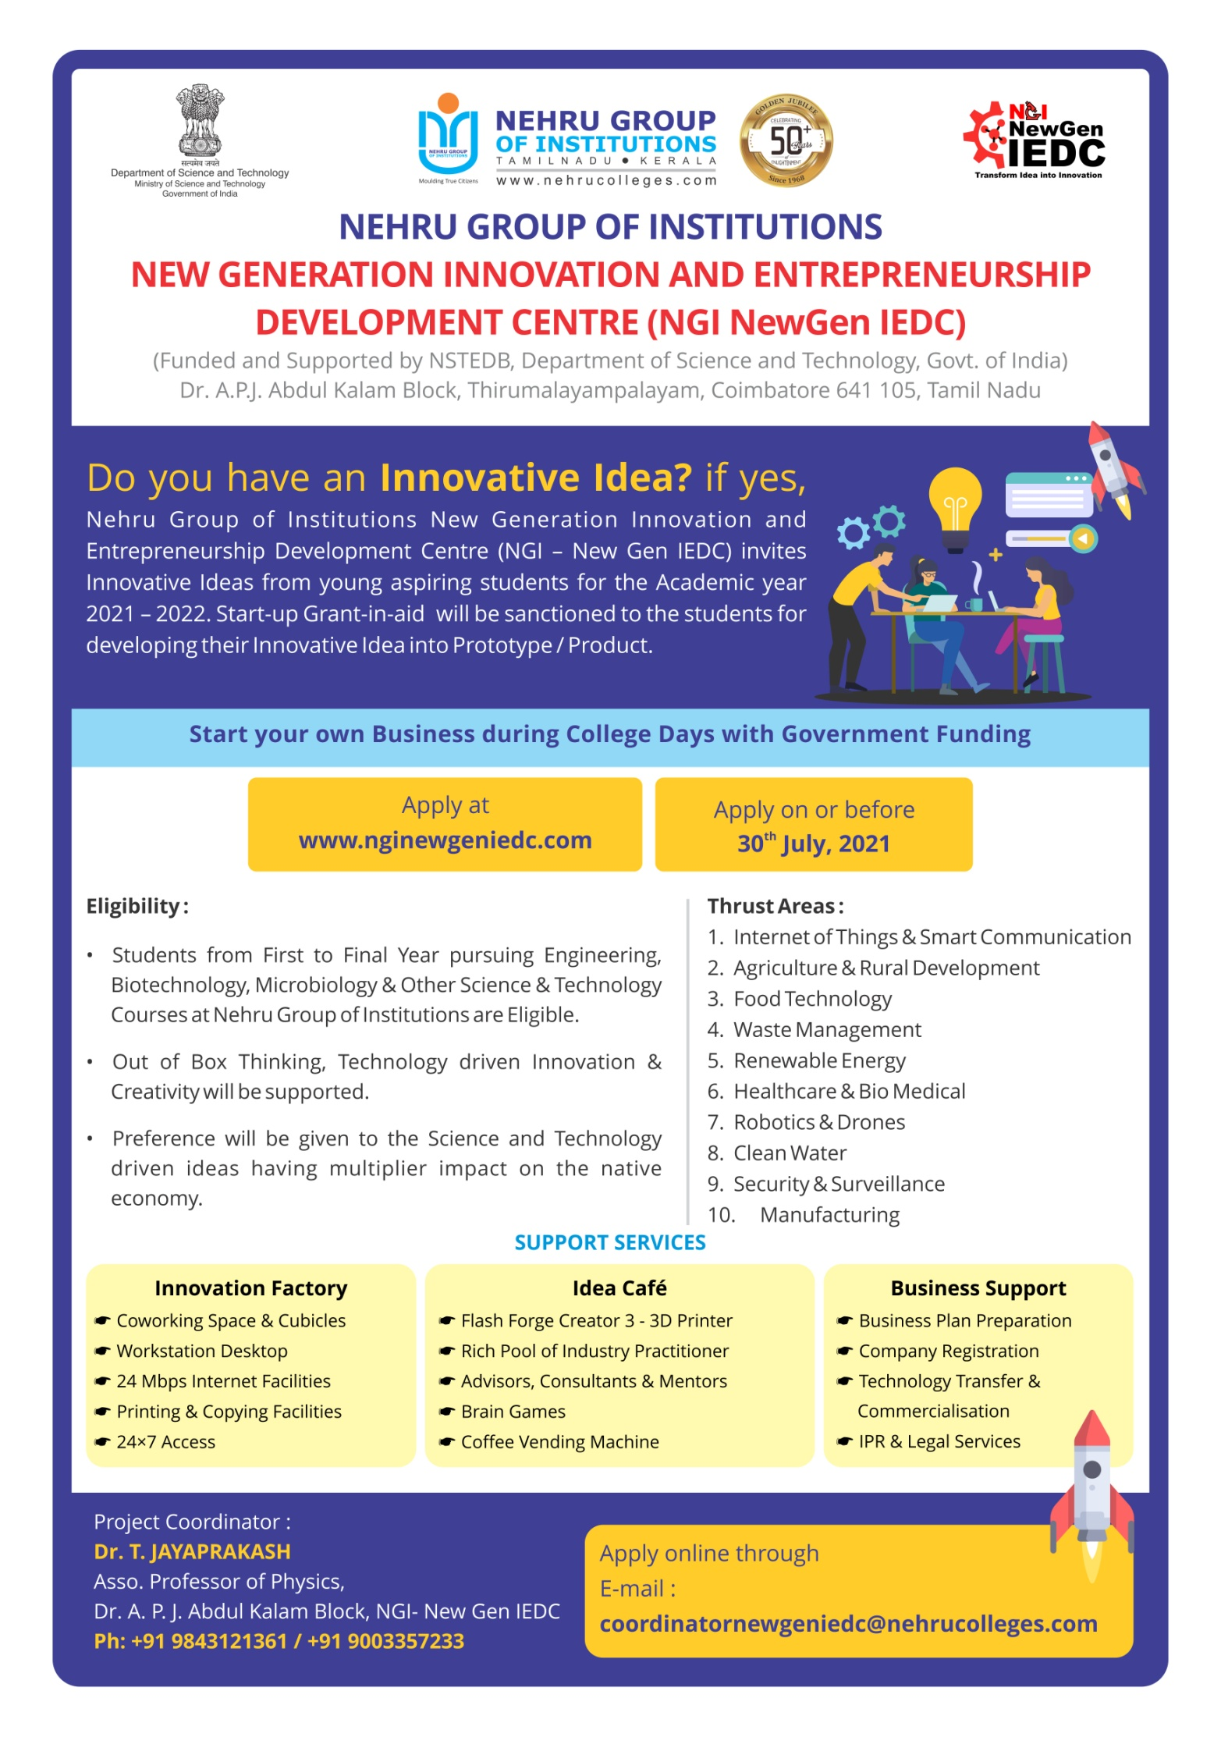

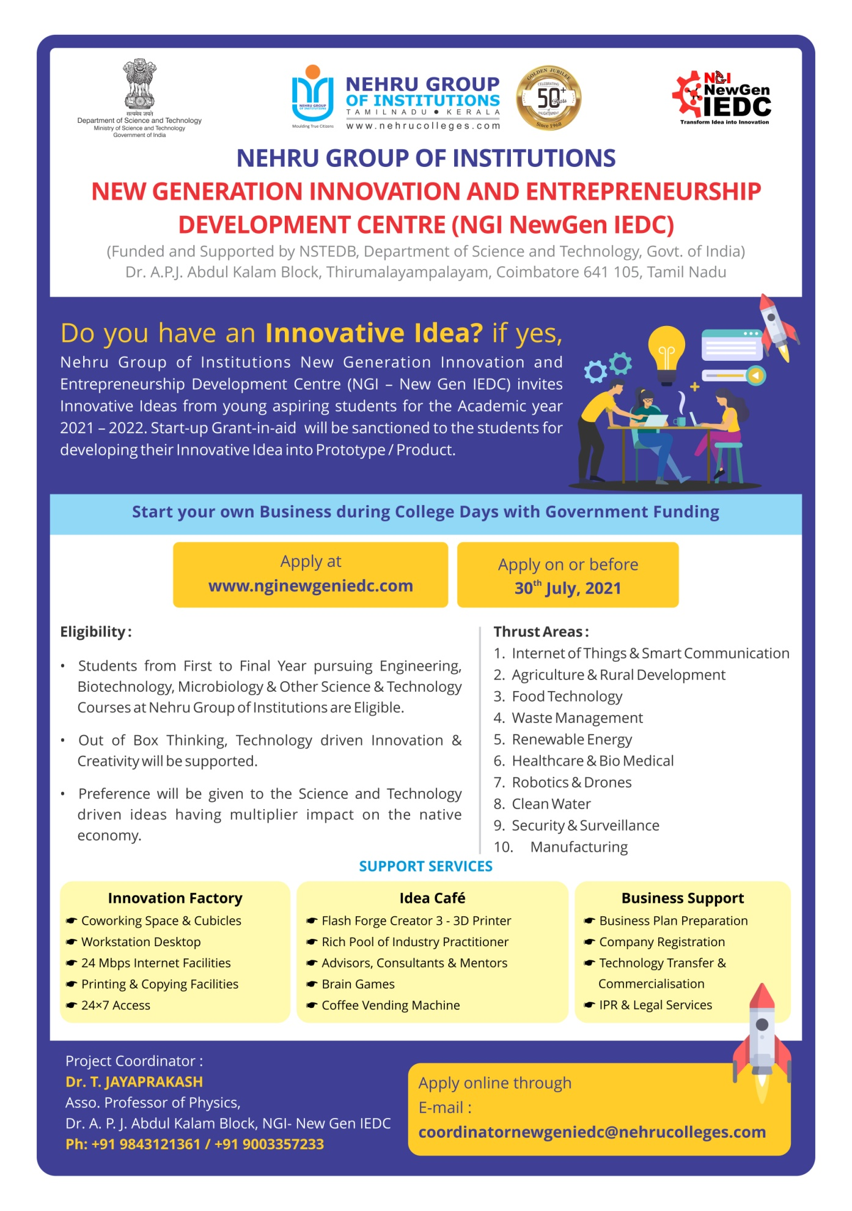
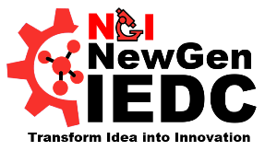
Nehru Group of Institutions
New Generation Innovation and Entrepreneurship
Development Centre

NGI NewGen IEDC
Supported by NSTEDB, Department of Science and Technology, Govt. of India
Pre Application Questionnaire

I. GENERAL INFORMATION
1. Name of the Applicant:
Sl.no | Name of the student | Year & Branch

2. Company Name (Existing/Proposed):

3. Title of the Project:

4. Status of Company Registration (if registered, please give registration number):

5. Student details: Individual / Team (Including Applicant’s Name):
S.no | Name, Residential Address  Email & Mobile Number | Degree | College | Year | Adhar Number

6. Details of the Mentor:
Name
Designation
College
Mobile
Email ID

II. PROJECT INFORMATION
- Thrust Area of Proposed Idea - Tick:

Internet of Things & Smart Communication Agriculture & Rural Development
Food Technology Waste Management

Renewable Energy Healthcare & Biomedical
Robotics & Drones Clean Water

Security & Surveillance Manufacturing

- Idea / Project Description:

- Technology adopted:

- Innovation:

- Scalability:

- Market / Commercialization potential:

- Current Status – Tick:

7)Current status of the Product/Prototype

- Idea Stage b) Feasibility Study

- Prototype Under Development d) prototype Developed

- Testing and validation f) Technology commercialization

- Market Research h) Others

- Provide Action Plan / Methodology & Estimated Development Time of the Product / Project:

Stages | Action Plan / Methodology | Time Schedule  (Days / Month)
1. | Collections of journals and articles | First 3 days of month 1
 | Review and consolidation of articles and preparation of the quotation | From day-4 to day-10 of month 1
 | Making a 3D sketch of the product in order to manufacture the Dual-axis Floating Solar Panel Tracking system | From day-11 to day-30 of month 1
 | Submission of quotation to various companies and receiving a quotation from them and checking the feasibility | From month 2
 | Ordering the components from the company | From month 3
2. | Implementation of the project | From month 4
3. | Testing and working of final alternation of the project | From month 4
4. | Prototyping | From month 5
5. | Report submission | From month 6
6. | Applying for patent

- Give a sketch either 3D Image or Animated Video of your prototype (Attach Separately):
Document attached
- Does your product/ service has an IP already generated? If not, is there a potential of the idea for IP creation?

III. RESOURCES

- What resources are required for producing your Product?

- Available Infrastructures at your College for the product development:

- Name of the other Equipments / Instruments required for the development of the product, other than at your College?

- Have you conducted any survey relative to your product/ service? If yes, please attach a copy. (Documentary evidences would be appreciated)

Yes (document attached)

- Do you have a Business Plan? If yes, please attach a copy. (Download Template from Website)

Yes (document attached)

IV. COMMERCIAL VIABILITY

- Demand of the product:

2.Social benefits of the product:

- Social Benefits:

- What are the regulatory standards surrounding the product and its use?

- Can you think of any Major risk attached to your business? How do you plan to overcome that?

V. FINANCIAL ASSESSMENT

- Cost of the Product:

- Estimated Budget for Product Development:
A. Cost of Raw Material:

S.NO | NAME | DESCRIPTION | COST | QUANTITY

B. Other Requirements:
Estimated budget:

VI. MARKETING

VI.MARKETING

- What is your targeted market and why?

- How will the product be introduced in the market?

- Who do you consider as your major competitors and why?

VII. ATTACHMENTS WITH THIS APPLICATION
Name of the document (Tick below, if attached) | Total number of pages = ………
CVs of the Team
Profile of Mentor

Business Plan

Surveys

Sketch of Prototype (3D Image/ Animated Video)

Self-Attested ID Proof (Aadhar Card -photocopy)

VIII. DECLARATION

I / We hereby declare that the above given information in the application are true and
best to my / our knowledge. I / We further declare that the project will be completed within One Year with my / our presence throughout the product development and the Final Product will be submitted to NGI NewGen IEDC, Supported by Government of India.

Name of Team Member | Signature

IX. CONTACT

Coordinator NewGen IEDC
Dr. T. Jayaprakash,
Associate Professor
Nehru Group of Institutions,
Coimbatore & Kerala
Ph: 9843121361
Email: coordinatornewgeniedc@nehrucolleges.com

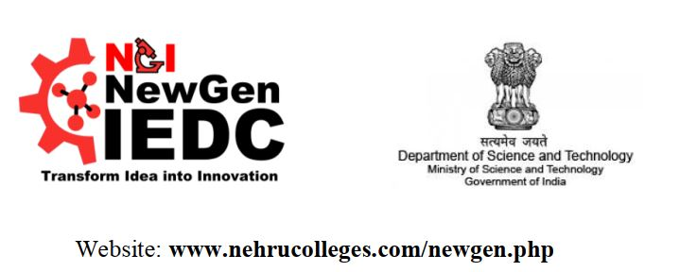

BUSSINESS PLAN

Table of Contents
I. Executive Summary
II. Company Description
III. Products
IV. Marketing Plan
V. Operational Plan
VI. Management & Organization

